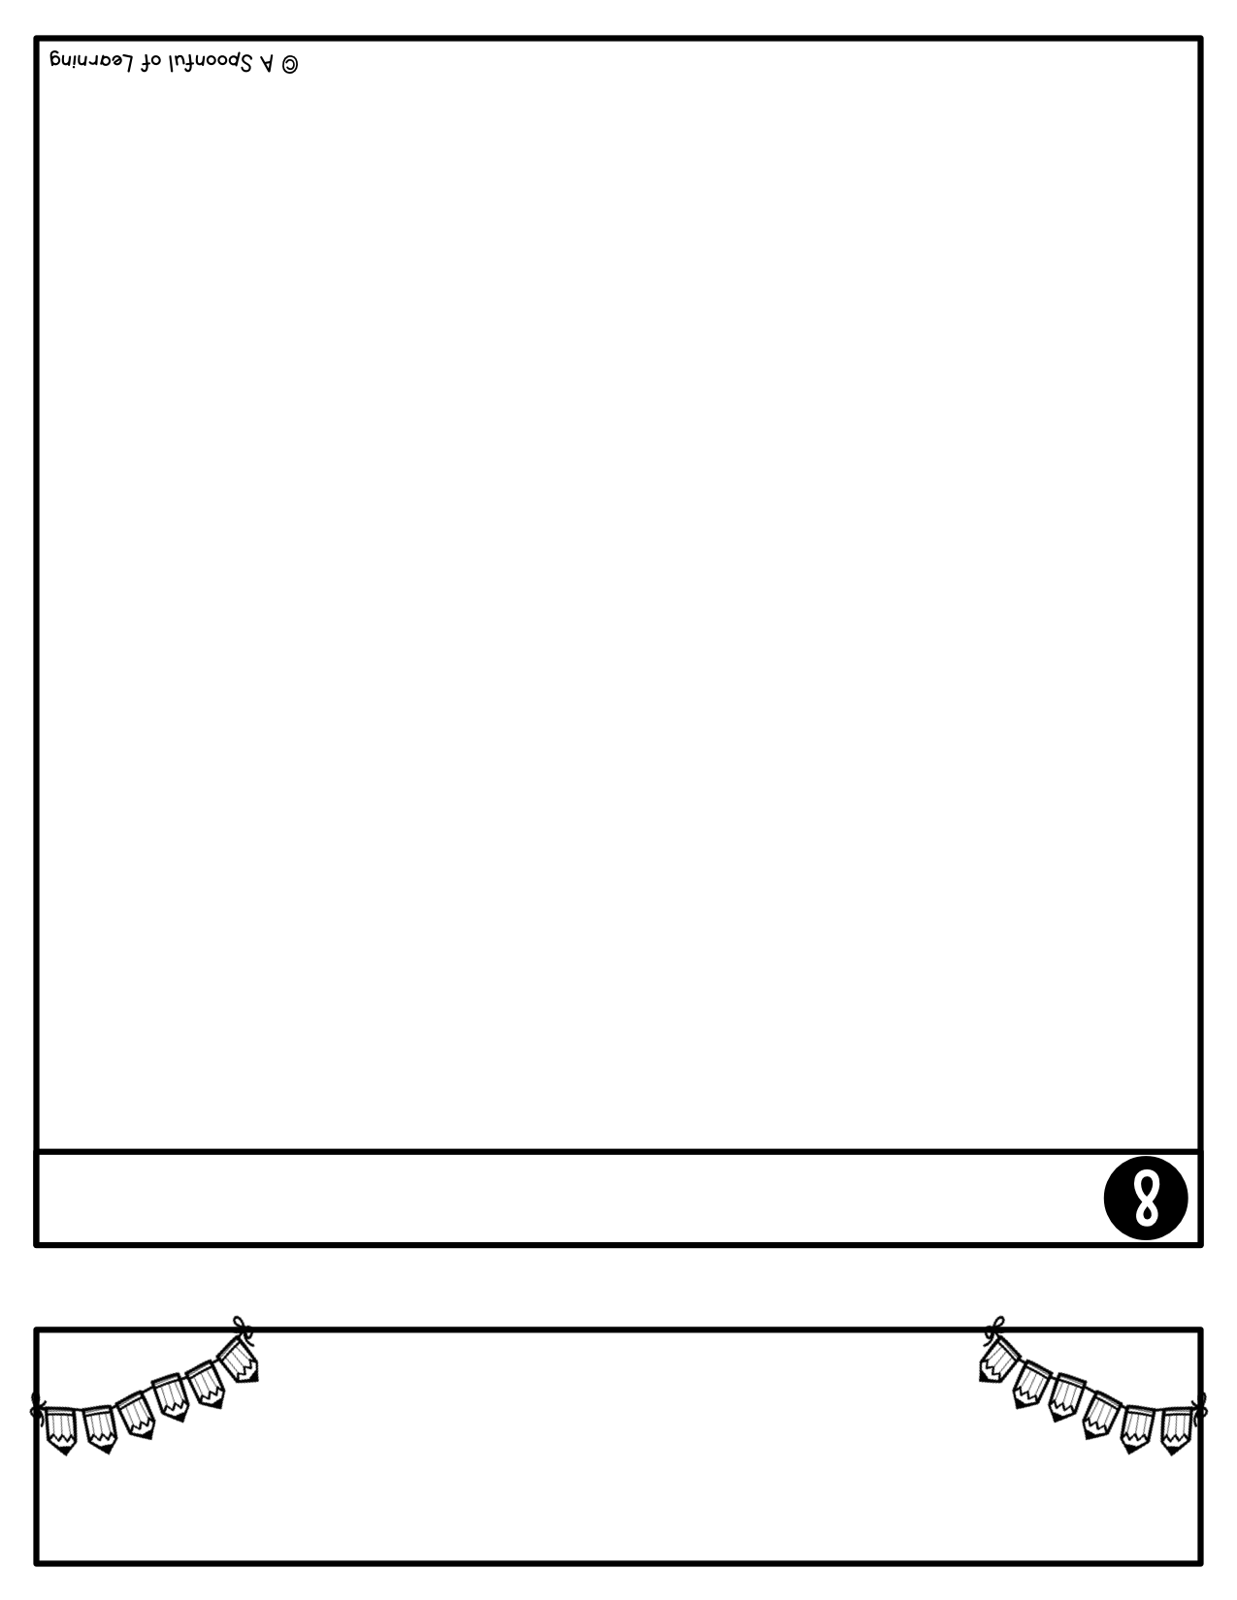

Communication is so important to me and is so important to a successful year! If you ever need to contact me, please do not hesitate. Here are a few ways that you can contact me:

**Email**: [dawn.morgan@k12.sd.us](mailto:dawn.morgan@k12.sd.us)

**School Phone**: (605) 996-2365

**School Address**:

1510 W. Elm Ave.

Mitchell, SD 57301

**District Website**:

johnpaul2.org

**Classroom Website:**

mrsdmorgan.weebly.com

Facebook: John Paul II School

Mrs. Morgan’s

Parent Handbook

Contact Information



Today your child brought home a take home folder with some papers

inside. This take home folder will be your child’s folder to keep all year. The

most important thing to remember about this folder is to

make sure your child brings this folder to school EVERYDAY. This

folder is very special and important and needs to be taken good care

of because your child will be bringing home papers that they

completed in class and I will also be sending papers home throughout

the school year to communicate with you. There will be a monthly calendar that will have the snack leaders on it that is to be signed with your initials daily so I know you have seen what is in the folder.

Inside the folder you will see on the left side KEEP AT HOME and on the right side BRING IT BACK.

This will not only help your child learn about their

right and left hand, but this is to let you know what papers need to

stay at home and what papers need to be brought back to school.

Anytime your child has papers on the left hand side, please

look over those papers with your child and take those papers out of

their folder because those papers can stay at home. Anytime your

child brings home papers on the right hand side, please look

over them and those papers in case you need to fill anything out.

Those papers will need to be brought back to school. Please keep the monthly calendar in this pocket.

Please let me know if you have any questions at all. Make

sure to check your child’s purple folder each day. They will love

showing you all of their hard work!

Thank you for all of your help!

Take Home Folder

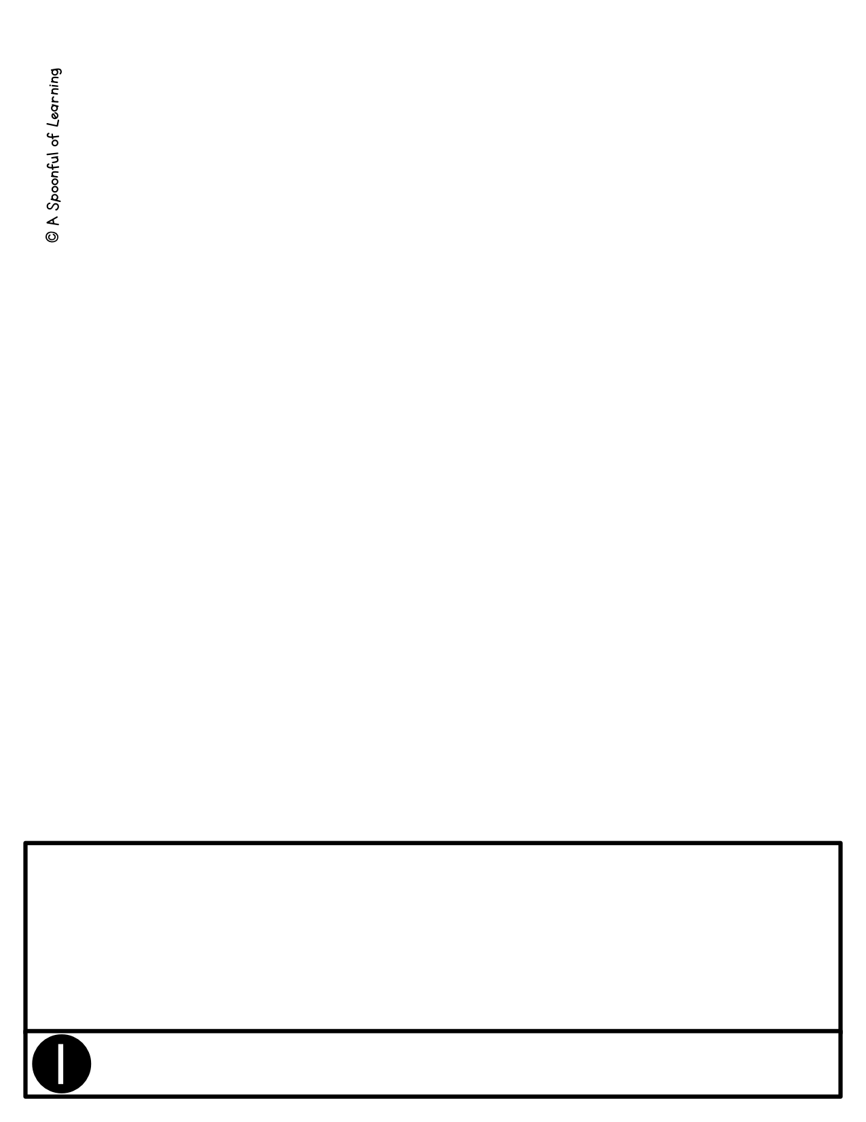

Welcome to Kindergarten!! I am Dawn Morgan and will be your child’s

kindergarten teacher this year! I am so excited for this year! We will be

learning so much and will be having lots of fun while doing so! I can’t wait

for all of the successes that will come this year with your child.

I look forward to having a great year!

Welcome



I love having a lot of fun in school and especially in our classroom! I love

to celebrate wonderful behavior and hard work! I also believe in having a

classroom where every student feels safe, comfortable, happy, and feels

cared for. I want each and every student to succeed to his or her highest

potential and I will do everything I can to make that happen. In order for this

to happen, I make sure that I have a well-managed class. One management

system I do in my class is 5 green faces. Each day that your child does as is

expected of them in my class, they will earn a star. Their goal is to earn a star

each day and on Friday if they have 5 stars, they will get to pick a prize out of

my treasure chest for their wonderful work and behavior!

Sometimes, we don’t always have our best days. And that is absolutely

okay! If a student does not do what is expected, I will give them a warning. If

the behavior continues, they will lose their star for the day. If the behavior

still continues after they lose a star, they will lose 5 minutes of recess for that

day. If the behavior still continues after losing recess,

I will email home to let you knowabout your child’s behavior for the day.

I am also implementing green and red choices. These choices are displayed and if they make good or green choices, their name will stay under the green, smiley face. If they make a poor or red choice, their name will move under the red, sad face. Each day they will have a card in their pocket on the back of their take home folder.

However, I always believe in giving students another chance. We all have

our off days! Therefore, I will always give opportunities for students to earn

back a star that they may have lost.

Each week we start over and they will again try to earn a

star each day so that they can have 5 stars by Friday to earn a prize! We will

also be working hard to earn classroom parties throughout the year to

celebrate our classroom successes!

**Classroom Management**

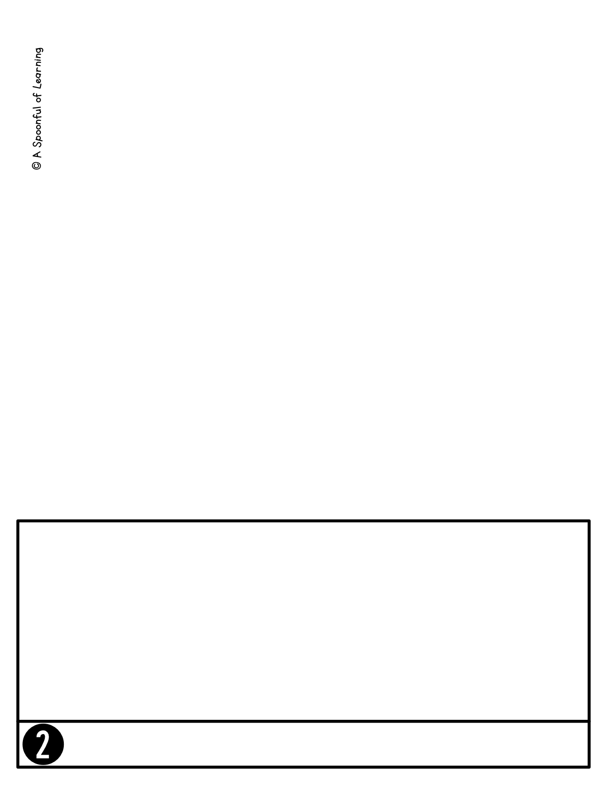

**Weekly Newsletter**

I absolutely LOVE letting you know what is going on in the classroom! Starting

next week, I will be sending home a classroom newsletter via email.

I will send a new classroom newsletter home every Thursday or Friday.

This newsletter will let you know EVERYTHING that we are doing in class, what

days we have specials (Music, Library, Art, P.E.), reminders, special events going

on in our classroom, and things going on at school. Make sure to look for the

newsletter in your email in box every Friday. Again, the first newsletter

will come home on the second Friday of school. The newsletter will then come

every Friday after that.

If you come across any information that is hard to understand or that you

have a question about, please don’t hesitate to let me know.



Your child’s safety is the most important thing. I like to make sure I know exactly

how they are coming to and from school. Please make sure to fill out the student

information/ transportation sheet if you have not already done so at the ‘Open House’.

If your child is riding the bus to and from school and you are unsure of what their

bus number is, please contact the bus company prior to the first day of school.

If you are driving your child to school or your child is walking in the morning, please

make sure they arrive to school by 8:15 and no earlier than 7:30 am.

School will start at 8:15 am. If you arrive after

8:20am, they will be considered tardy.

If your child is taking the yellow bus home at the end of the day, there will be a teacher on duty every day to assist your child. Please discuss and practice their bus routine at home so they feel comfortable about riding the bus.

If you are picking up your child at the end of the day, you can pick them up from

the office or the East doors starting at 3:00 pm.

Please let me know who will be picking your child up each day because I am not able

to let them go home with anyone that I or the office is not aware of. This is for your

child’s safety. If the person who picks them up ever changes throughout the year,

please let me or the office know.

**Transportation**

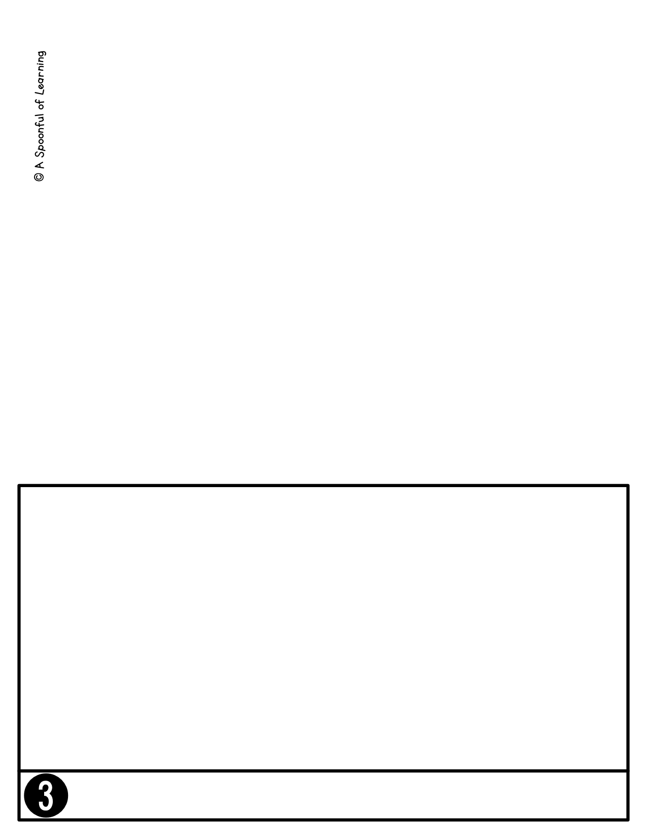

**Hours**:

School begins each day at 8:15 am. Students may arrive by 7:30 am every

morning and we will have supervision in the MPR each day and then recess from 8:00 to 8:10 am. I know that the

mornings can get very busy at times. Please make sure to try your best to get your

child to school on time so that they can get settled in for the day with the class

and do their daily morning routine with the rest of the class.

School ends each day at 3:15 pm. If you are picking your child up from school at the

end of the day, you will be able to pick him or her up from the office or at the East Doors starting at 3:00 pm. They will go to the office after 3:30 pm.

**Tardies**:

School starts at 8:15 am and your child will be counted tardy if they are not in the room by that time. Please be considerate of this.

Absences:

Throughout the year, there will be times that your child may get sick,

need to go to the doctors, etc. If your child is absent from school please make sure

to contact the office at (605) 996-2365 or email me at dawn.morgan@k12.sd.us

regarding his or her absence.

**School Hours & Absences**



**Lunch**

Each day we will be eating lunch at 11:30-12:00 am. Your child can have lunch at

school or you can pack a lunch for your child to eat.

**S p e c i a l s**

This year your child will be taking different specials each day of the week. These

specials include: Music, Library, Smart Labn , and Physical Education (P.E.). We also have Mass on Wednesday at 9:00 am and Adoration and Priest Visits on Thursday. On Fridays we also have Art and meet with our 6th Grade Buddies. Here are the

days that your child will be participating in these specials:

Monday- Smart Lab

Tuesday- Library and P.E.

Wednesday- Smart Lab and Music

Thursday- Smart Lab an P.E.

Friday- Music

**Lunch and Specials**